CHAPTER FOUR

IMPLEMENTATION AND TESTING

* 1. **INTRODUCTION**

This chapter deals with the implementation and testing phase, which constitute the main part of the new system. The software and hardware required for the implementation of the fire notification sytem are as follows:

**4.2 Choice of Development Tools**

So many programming languages were considered in the cause of designing this software. A lot of factors were put into consideration which includes online database access, data transmission via networks, database security, database retrieval online, multi user network access, online data capture, etc. The choice of android studio for the mobile application are because of **Faster Deployment of Fresh Builds, More Accurate Programming, Faster Programming and Testing, Inclusive App Development, better app indexing which helps in creating and adding indexable URL links to the app and it is meant to be used by mostly Android phone users, seeing that majority of the populations in Nigeria, especially Benin uses Android phones.** The choice of using html, CSS and JavaScript for the fire service portal which are of one of the best set of web programming language because its user friendly nature and ease of write ability, supported by all kinds of browsers, and its unique functionalities and libraries.

4.2 **System Requirement**

In order to realize this project, the following software and hardware components were used:

**4.2.1 Software Requirements**

The software requirements for the fire service portal includes:-

* A minimum of windows 7 operating system
* A web browser such as firefox, uc browser or chrome.
* The portal URL saved on the web browser…

Software requirements for the mobile app users

* An android operating system, minimum of version 5.0
* GPS

**4.2.2 Hardware Requirements**

**Fire service portal**

In the cost of the design, the software developed needed the following hardware for an effective and efficient operation of the new system.

1. Intel Computer System (at least a dual core)
2. A minimum of 2GB RAM.
3. Enhanced keyboard.
4. At least 120GB hard disk.
5. At least a 14 inches display unit (monitor or screen), for clearer view of map.
6. An uninterruptible power supply (UPS) units

**Mobile app users (reporters)**

1. An android phone that is GPS supported and with a working camera

**4.2.3 People Ware (Personal Requirements)**

The implementation of the web app is limited to fire service personnel in the ICT department, while anyone using an android app with the specifications previously given is eligible to using the mobile application as its going to be open source.

**4.8 SYSTEM IMPLEMENTATION**

By Implementation, I mean the realization of the application, or execution of the plan, idea, model, design, specification, standard, algorithm, and policy stated in the previous chapter.

**4.5 Testing**

In this session, execution of program and evaluation of built application is done to detect errors. The below information gives the detail of the testing and their respective results

**4.5.1 Unit testing**

The different unit of this project was tested by different individuals and its workability perfectly approved the achievement of the stated aims of building the entire system. This comprise of the test data, expected test result and actual test result

**Table 4.1 unit testing**

**For the mobile application**

|  |  |  |
| --- | --- | --- |
| **The Test Data** | **Expected Test Result** | **Actual Test Result** |
|  |  |  |
| Home | Interface containing the dashboard, result of report, news | Expected result was gotten |
| Dashboard/menu | Expected to see the | On clicking on the dashboard button subsystems/menu were swiped in or poped out. |
|  | display form of this |  |
|  |
|  | Project and gives access to sub systems in the application |  |
|  |  |  |
| About us |  | On clicking on the ‘about us’  The expected brief was displayed |
|  | This is supposed to display a brief information from fire service and the purpose of the application |  |
|  |  |  |
|  |  |  |
|  |  |  |
| Report | Expected to see the Report | A click on the report button should open a session(form)  Where the reporter fills in needed details in and finally submits it. |
|  | command button so |  |
|  | That reporter can fill in necessary information. |  |
|  |  |  |
|  |  |  |
|  |  |  |

This table 4.1, which is the unit testing table explains how the system is being tested individually and the successfulness of each of them.

**Unit testing For the web application**

|  |  |  |
| --- | --- | --- |
| **The Test Data** | **Expected Test Result** | **Actual Test Result** |
| Dashboard | Interface contains a map that shows all the reports coming from the users app. | Expected result was gotten |
| Reports | Interface should contain a list of reports and each report can be accepted or declined. | On clicking on the accept button the report status changed as expected. |
| Manage News | The interface helps in creating and managing news. | A new news Item was added and shown on the mobile app after a news item was added. |
| Manage Notifications | The interface helps in creating and managing notifications. | Expected Result was gotten |

**4.5.2 System Testing**

System testing of software or hardware is testing conducted on a complete, integrated system to evaluate the system's compliance with its specified requirements. System testing falls within the scope of **black box testing**, **and as such, should require no knowledge of the inner design of the code or logic.** In this, the accuracy of the program was tested with some varying data. This gives the assurance that the new system has achieved its purpose and objectives.

**Homepage**

It’s the first page encountered when the app is opened or turned on. it contains results of reported incident, whether resolved, ignored or open, and the dashboard. It also contains a record of individual user report which includes time, description and status of report. It also contains some news on fire incidents.

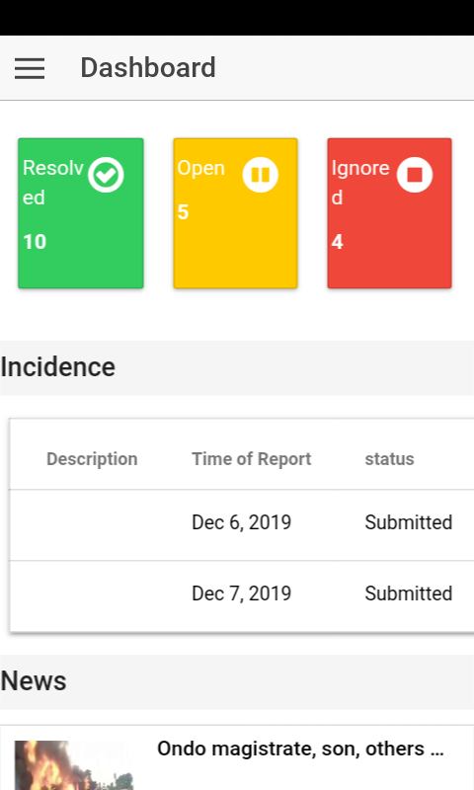

**home page interface of the mobile application users**

**Dashboard/ menu**

This feature allows access to other subsystem i.e. the” report” session and the “about us” functionality. As the “home” feature still leads user back to the home page.

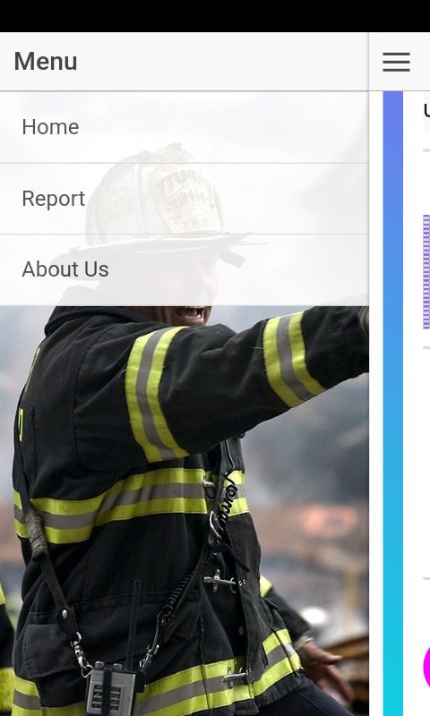

**Dashboard/ menu interface**

**Report session**

In this session a form is displayed as shown in the diagram below. It contains the mobile application user’s information which includes name, phone number, description of incident (optional), and address (auto generated because as long as data is on and the mobile application is opened, the phone GPS comes on automatically). Also there is a feature to take pictures (named “take a photo”) as evidence of fire incidence. This is where the most important functionality of the application lie.

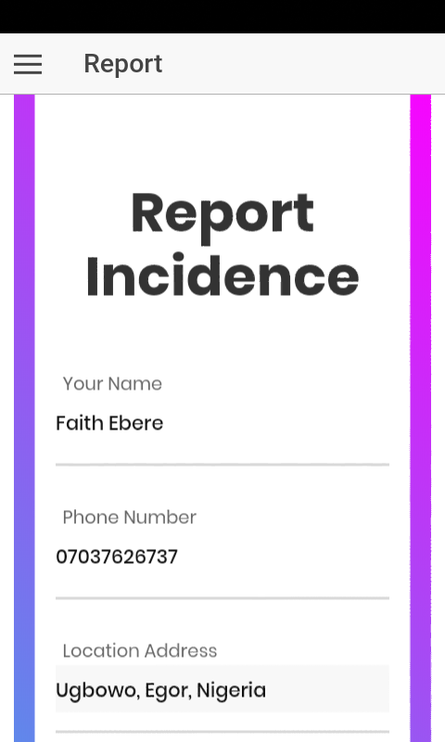 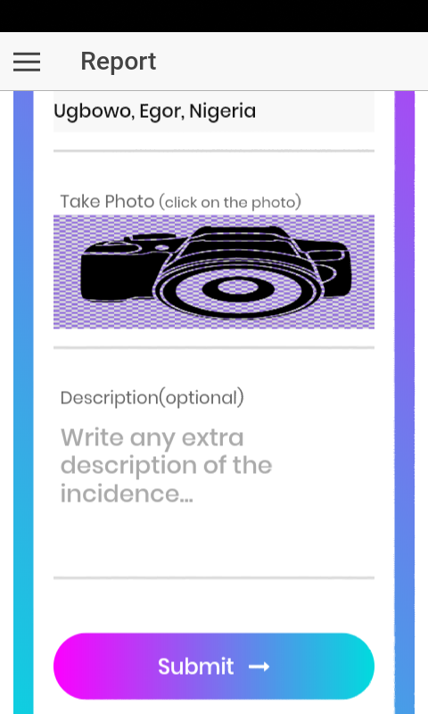

**Report session of the mobile application**

**Note;** a notification pops up after submission, to tell if report was successful or not. The catalogue is shown in the diagram below

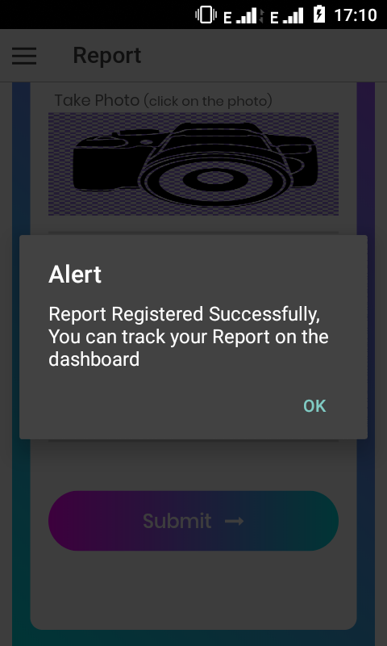

**Catalogue displaying report success**

**System testing for web application**